BOM (Bill Of Materials)

This document describes which components are required to assemble the unit.

Note: the URLs in this document are used as example and often show with a picture the component required – most of this is better ordered via AliExpress, or via your local electronics shack. Prices will be better there as well.

Inhoudsopgave
BOM (Bill Of Materials) 1
NeoPixel strand – 8 leds 2
Power Circuit 4

NeoPixel strand – 8 leds
pieces | details
8 | NeoPixel Button PCB  https://www.adafruit.com/product/1612  note: these can be ordered at different locations and in different pack sizes, for instance:  https://nl.aliexpress.com/item/32966321827.html?spm=a2g0o.productlist.0.0.30c6206aaSIyUB&s=p&algo_pvid=7773d8dd-fb90-427f-bdfd-372e26ecd068&algo_expid=7773d8dd-fb90-427f-bdfd-372e26ecd068-1&btsid=2594c913-d050-4b27-a4c1-55f1e67105bb&ws_ab_test=searchweb0_0,searchweb201602_8,searchweb201603_55
1 | Resistor, 470 Ohm, ¼W, 5%  https://www.kiwi-electronics.nl/Weerstand-470-ohm-1-4-watt-5-procent-10-stuks
1 | Capacitor, 100 uF, 16V  https://www.kiwi-electronics.nl/componenten-onderdelen/componenten/condensatoren/elektrolytische-condensatoren/100uf-16v-condensator  note: the NeoPixelUberGuide uses 1000 uF, but this seems a bit much for the amount of NeoPixels we use.
3 (colors) | Wire, about 50 cm  https://www.kiwi-electronics.nl/componenten-onderdelen/prototyping/draad-kabel/aansluitdraden-set-met-solide-kern-6x7-5m-0-65mm
3 | Jumper wires, 15 cm, female-female  https://www.kiwi-electronics.nl/componenten-onderdelen/prototyping/jumperwires-kabeltjes/jumperwires-10-stuks-15-cm-femafe-female

Optional:
pieces | details
1 | Heat shrink tubing  https://www.kiwi-electronics.nl/krimpkousjes-assortiment?search=krimpkous&description=true  Or: some tape will do as well. The intent is to shield some of the open connections.

Final result:
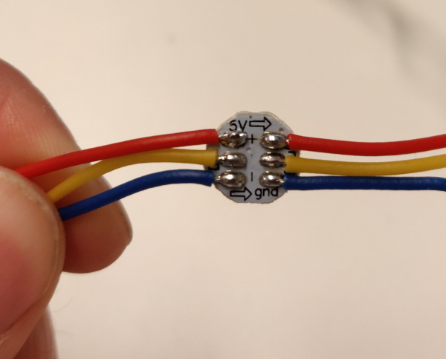
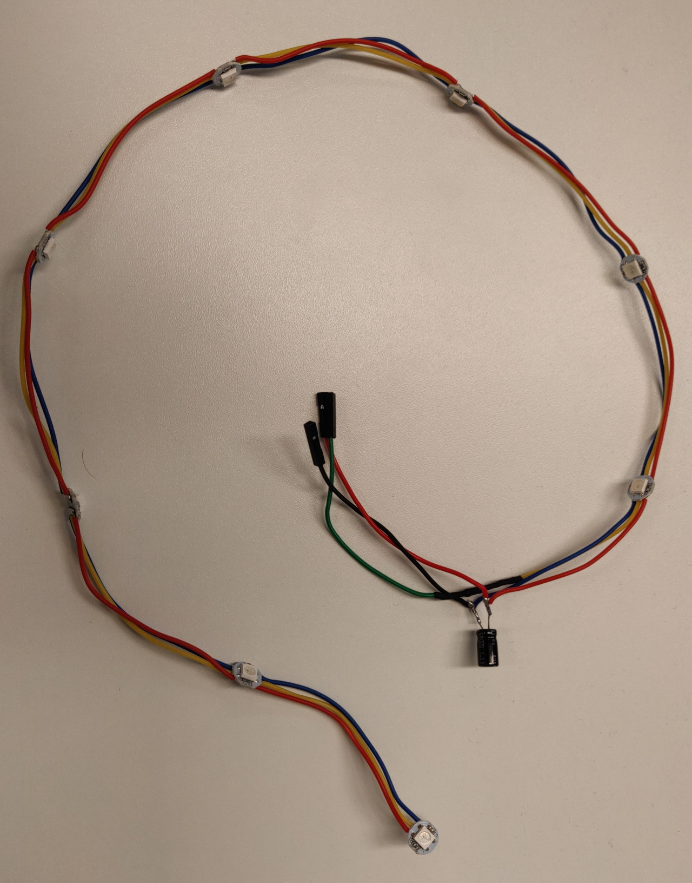

Power Circuit

pieces | details
1 | Battery Charger with charge protection  https://nl.aliexpress.com/item/32971733016.html?spm=a2g0o.productlist.0.0.4cca7c58spW1ju&s=p&algo_pvid=dabfa38b-45f1-411f-ba93-54e312cd690b&algo_expid=dabfa38b-45f1-411f-ba93-54e312cd690b-0&btsid=028f145b-4d9e-4104-bd5d-bf5fdbf62273&ws_ab_test=searchweb0_0,searchweb201602_7,searchweb201603_53
1 | Step down convertor  https://nl.aliexpress.com/item/32653810603.html?spm=a2g0o.detail.1000060.1.27705ff6Q82WkR&gps-id=pcDetailBottomMoreThisSeller&scm=1007.13339.146401.0&scm_id=1007.13339.146401.0&scm-url=1007.13339.146401.0&pvid=1edb1c1d-f0cd-46ec-8b3e-3037288c13d4
1 | Battery – LiPo – 18650 – 3400 mAh  https://nl.aliexpress.com/item/33016517000.html?spm=a2g0o.productlist.0.0.65f0d1f7bglIBc&s=p&algo_pvid=adb98d3f-064e-493e-9de7-f41c00bf5d4c&algo_expid=adb98d3f-064e-493e-9de7-f41c00bf5d4c-5&btsid=cf7c52b6-e454-426b-8957-5a8fea3eee94&ws_ab_test=searchweb0_0,searchweb201602_7,searchweb201603_53  note: should order in your native country, typically they do not pass customs
1 | Battery holder  https://nl.aliexpress.com/item/32824489601.html?spm=a2g0o.productlist.0.0.7f6b38bfQkWGdL&s=p&algo_pvid=f4945b0a-0112-498f-bf8f-3457bd99512c&algo_expid=f4945b0a-0112-498f-bf8f-3457bd99512c-4&btsid=686eff58-61dc-418e-bfbf-54a6e8c47fc6&ws_ab_test=searchweb0_0,searchweb201602_7,searchweb201603_53
9 | Pin header, male  https://www.kiwi-electronics.nl/40-pin-header-strip-5-pack?search=pin%20header&description=true

Optional:
pieces | details
1 | Heat shrink tubing  https://www.kiwi-electronics.nl/krimpkousjes-assortiment?search=krimpkous&description=true  Or: some tape will do as well. The intent is to shield some of the open connections.

Final result:

